International E-Marketing to China:

How Live Streaming is influencing buying behaviour

(The Example of Taobao Live)

**Abstract**: In the modern world dominated by information technology, communication channels like television, radio, newspapers and magazines are becoming outdated and outrun in popularity by the internet media. The closed ecosystem of the online channels in China with the most foreign apps blocked and replaced with the Chinese analogs provides for a completely different, independent from the outside world environment for online marketing. Social media is an extremely powerful tool for introducing new products and building customer trust. However, foreign businesses aiming to enter the market in China need a blueprint on how to properly utilize this potent instrument, what is the right strategy and which target consumer is it the most suitable for.

This article provides general guidelines on digital marketing to China, summarizes information about online marketing in general, introduces the trend of live streaming and measures its influence on buying behavior among different consumer age groups to be properly put into use by international business owners aiming to enter the Chinese market.

**Keywords**: e-commerce; international marketing, live streaming; buying behavior;

**Contents**

1. Introduction

x 1.1 Research background and significance

x 1.1.1 Background

x 1.1.2 Significance

x 1.2 Current State of Online Marketing in China

x 1.3 Introduction of the case platform - Taobao Live

2. Marketing Context in China

x 2.1 Traditional and Digital Marketing

x 2.1.1 Traditional Marketing

x 2.1.2 Internet Marketing

x 2.1.3 Internet Consumption

x 2.1.4 Recent statistics of Internet Users in China

x 2.1.5 Government e-commerce policy for international businesses

x 2.1.5.1 The 2019 E-commerce Law

x 2.1.5.2 The 2021 New Rules Addressing Live-Streaming

x 2.2 New Trends in Marketing

x 2.2.1 Definition and Characteristics of Live Streaming

x 2.2.2 Classification of Live Streaming Platforms

x 2.2.3 Influencers and KOLs in China

3. Theoretical Analysis

x 3.1 Study on buying behavior and its implications for Live Streaming

x 3.1.1 Definition of buying behavior

x 3.1.2 Stages of Decision Making Process

x 3.1.3 The four types of buying behavior

x 3.1.3.1 Complex buying behavior

x 3.1.3.2 Dissonance-reducing buying behavior

x 3.1.3.3 Habitual buying behavior

x 3.1.3.4 Variety seeking behavior

x 3.1.4 Factors affecting consumer buying behavior

x 3.1.4.1 Social factors

x 3.1.4.2 Personal factors

x 3.1.4.3 Psychological factors

x 3.2 Study on Purchase Intention:

x 3.2.1 Purchase Intention Based on Consumer Attitudes

x 3.2.2 Based on Theory of Planned Behavior

x 3.2.3 Based on Technology Acceptance Model

x 3.3 Study on OCE (Online Customer Engagement)

x 3.3.1 Definition

x 3.3.2 Influence on Purchase Intention

4. Methodology

x 4.1 Choice of the Research Method

x 4.2 Designing an insightful survey

5. Results and Conclusions

x 5.1 Descriptive statistics

x 5.2 Testing the hypotheses against the answers

x 5.2.1 H1. Taobao Live influences buying behavior because its environment allows users to familiarize with the products in more detail.

x 5.2.2 H2. Taobao Live successfully handles dissonance reducing buying behavior by drawing user's attention to the products, therefore providing bigger visibility and perceived availability for consumers.

x 5.2.3 H3. Taobao Live is influencing buying behavior, because it provides a highly interactive platform both among users and between the users and the company.

x 5.2.4 H4. Taobao Live influences buying behavior because it provides a platform, where consumers can be highly engaged with the brands, and form brand loyalty.

x 5.3 Implications for International Businesses

x 5.4 Study Limitations

x 5.5 Suggestions for Further Research

References

Appendix (Questionnaire)

(x indicates that the part of the writing has been finished)

# 1 Introduction

## Research background and significance

### 1.1.1 Research background

Since the year 1998, when the Internet in China has become open not merely as a national infrastructure for communication and scientific research but as a tool for the ordinary citizens, the number of the Internet users and related technological advancements have been growing rapidly. In the present time the all-encompassing Internet technology surrounds us everywhere we go in our normal day to day life. It has become the main medium for communication, entertainment, shopping, and its range of functionality is constantly expanding. Between the years of 2009-2014 several major online media platforms such as Facebook, Twitter, YouTube, Google services, etc. have been blocked in China due to the censorship, which allowed local channels to be used instead. That led to a certain ecosystem being created within the Chinese digital space and had set an alternative way of development. Furthermore, such operations as shopping, ordering food delivery and payment have been highly digitized, which made China one of the most advanced e-commerce industries in the world. Hence the deep integration of digital technology into the lives of Chinese citizens, online marketing has become one of the most effective ways of advertisement and is widely used by businesses and corporations in China. While the online media has already been highly popular among the Chinese users, the recent COVID-19 lockdown has propelled it even further. Now, besides the ordinary content marketing performed via long and short videos on social media platforms, the new trend of live streaming has become a rapidly growing industry and is estimated to be worth $60 billion annually. Alibaba’s Taobao Live has been specifically chosen as the most outstanding example of a live streaming platform for this paper. With the most significant market share of 80%, Alibaba’s Taobao Live remains the leader among the other large live streaming platforms, such as Baidu, JD.com, Douyin, Tiktok, Kuaishou, MOGU and others. With the recent significant gain in popularity and its promising estimated growth, live streaming presents an innovative opportunity for international businesses to enter the Chinese market.

### 1.1.2 Research significance

On the basis of understanding the current condition of the online marketing field and analyzing the trends, this article will draw the knowledge from the latest international and online marketing theories to deeply study the potential benefits and applicable tactics. Furthermore, an online survey will be conducted among the Chinese Internet users of different age groups in order to supplement and support the information suggested in the article. It is not only a question of promoting a single foreign business to the Chinese consumers, but rather a question of the globalization and the mutual benefit between countries, that the modern technology is able to offer. Exporting and importing goods does not merely help large scale businesses to succeed, it also helps national economies to grow and expand. Consumers and businesses can benefit from buying the products that are not produced locally, but are available for purchase online from a business abroad. If more international business owners know how to properly present their products on the Internet, it means increasing profits and the sales potential for the international businesses, as well as possible reduced costs and new products availability and, as a result, higher economic efficiency for the importing country. It is hoped that at the end of the investigation there will be a clear indication of the potential of Chinese online media channels, and live streaming platforms in particular, in assisting foreign businesses aiming to penetrate the Chinese market, as well as statistical identification of what kind of target audience these marketing campaigns would be the most suitable for and what kind of marketing techniques would be the most effective. The insights received in the process of this investigation can be used to support further academic research in the field of international online marketing.

## Current State of Online Marketing in China

By the end of 2020, China had 989 million internet users, according to figures released by government agency China Internet Network Information Center (CNNIC). More than 98 percent of these users are accessing the internet through their mobile devices making China the first country to be a “Mobile First Nation”. In 2021, mobile internet is predicted by R3 to take up 17% of China’s total IP traffic, indicating that mobile traffic has grown at a compound growth rate of 56% since 2016. With the continuous improvement of network connectivity and Chinese consumers who are increasingly using their phones in their day to day lives, brands understand the importance of focusing on digital marketing strategies such as live broadcasting, short videos, and personalized content.

$75.33 billion is an estimation of China’ online advertising revenue of 2020, which makes China the second-largest market worldwide for digital advertising. Digital ad revenue in China grew 23% in 2020 as marketers invested in short video, e-commerce and social media. The growth is remarkable given that the Covid-19 pandemic saw average media spend drop 15% between the first and third quarters of 2020, according to information on the web ([thedrum.com](http://www.thedrum.com.)). The publisher outlines that social key opinion leaders (KOL) and performance media investment were the fastest-growing media types in 2020 as content became a key focus for marketers looking to increase engagement and conversion through social commerce. It indicates the rapid increase in demand for advertising on live streaming platforms.

Among all of the diverse marketing channels in China, today the online video ads market is worth 46 billion yuan (6.8 billion dollars), the OTT (Over The Top) market 4 billion yuan (592 million dollars), news ads market 42 billion yuan (6.2 billion dollars) and, online live broadcast marketing market 3.4 billion yuan (503 million dollars) according to marketingtochina.com.

## Introduction of the case platform - Taobao Live

Taobao is a large Chinese online shopping platform. It was founded by Alibaba Group in 2003 and it is now ranked as eighth most visited website in the world according to Alexa Website ranking. Consumer to consumer (C2C) retail is facilitated in Taobao marketplace by providing an opportunity for small businesses and individual entrepreneurs to open online stores. Taobao goods are payable by online cellphone accounts, and are usually sent to clients by an express delivery service offered by the store. In 2018, Alibaba launched a live streaming service named Taobao Live. This service was created in order to help online retailers market their products utilizing the online phenomenon called social shopping. The service is integrated into the Taobao shopping app and divided into categories for users according to their interests, such as food, clothes, cosmetics, jewerly, electronics, and even cars. It’s become an important tool for brands in communicating with their customers. It allows consumers to shop while watching hosts review and recommend products.

The platform has seen significant growth in popularity and success, with 84 stores using this service reporting $7.4 million in sales. According to the latest Taobao Live data, the gross volume of goods generated by the platform has grown by 150% per year for three consecutive years. At the end of 2019, consumers spent over 350,000 hours every day viewing content on the platform. In the meantime, the newly registered accounts have almost doubled.

The use of the platform continued to grow in the recent months, as the brands and merchants suffering from the coronavirus emergency have increasingly turned to live streaming in order to continue their business.

“The future of shopping will be more dynamic, interactive, and driven by real-time feedback. Live streaming offers a peek into that future and new possibilities,” said Yuan, head of content operations at Taobao Live.

# 2 Marketing Context in China

## 2.1 Traditional and Digital Marketing

2.1.1 Traditional Marketing

Chinese marketing environment is drastically different from the western ones, so simply copying marketing strategies that foreign business used in their countries won't work here. Western brands usually define the brand image as the sum of their products, launches, and campaigns, but brand image and position is much more important in China. A huge array of external factors can also affect the success of a brand in China including political, economic, social-cultural, technological, legal and environmental.

Traditional marketing is a conventional mode of marketing that helps to reach out to a semi-targeted audience with various offline advertising and promotional methods.

Many of the common and most tried offline marketing tactics come under the following five major categories: print (magazines, newspapers, etc.), broadcast (TV, radio, etc.), direct Mail (catalogues, postcards, etc.), telephone (telemarketing, sms marketing, etc.), outdoor (billboards, fliers, etc.).

Traditional marketing may have evolved over the past few decades, but the fundamental aspects remain the same. The selling techniques that are used today heavily rely on the four P’s of marketing: product, price, place, and promotion.

Product: Effective marketing starts with a good understanding of your own product. Which could be an intangible service or type of a good that fulfills the demand of a target market.

Price: The overall cost of the product depends on how well you know it. Price is always the determining factor when it comes to things like supply, demand, profit margin, etc.

Promotion: How you get the word out about your product and market it to your target audience is promotion. Any method that helps you promote the product and help it gain more exposure comes under promotion — whether it is advertising on a billboard or setting up an ad campaign on Facebook.

Place: Traditional marketing heavily relies on getting your product in front of your target audience at the right time and place. Which also means pricing it right. In the marketing world, placement plays a crucial role. Because when a product is placed in an ideal location, the chances of converting prospects to customers or clients increase manifold.

On the surface, digital marketing may look different than traditional marketing in a big way as it is all about the fourth P: promotion. However, the fact of the matter is, digital marketing is highly effective because it does not ignore any of the four P’s of marketing. It rather uses each one of them in a unique manner, and sometimes even better than traditional marketing.

2.1.2 Internet Marketing

It is vital for the enterprise to pay attention to the different environments they operate in, because it directly affects its productivity. Richard Mayer (2003) considered it essential to see the division between the two environments of internet marketing and internet consumption. Analyzing the environment of internet marketing helps businesses discover opportunities and spot threats to avoid, therefore promoting its development. It is evident that in the digital marketing environment new characteristics are added to the consumer buying behavior. These new characteristics include but are not limited to more targeted personalized marketing, seeking convenience, opportunities for increasingly more rational purchase decisions. For companies to meet the consumer’s needs better, it is crucial to understand all the nuances of how the internet marketing environment works.

The internet marketing environment is mainly comprised of macro political and legal environment, social cultural environment and economical environment.

Political and legal environment refers to the specific laws and political regulation of the country or a certain region. This environment is the foundation of any business activity and the basis of internet marketing. The role of government in political environment is mainly reflected in two aspects. (Mayer 2003, 123) On the one hand, the government promotes economic development by formulating a series of policies to create a sound economic environment. On the other hand, the government restricts and standardizes business activities of enterprises, ensuring that the whole market activities are conducted in a regular way.

Economic environment refers to different economic conditions and situations that the businesses face while carrying out their activities. It has the biggest impact on the digital marketing, since it is crucial that online marketing is conducted in a relatively well economically developed region with good economic potential. It requires a well established network infrastructure as well as a large amount of internet users. Furthermore, these users are supposed to have a corresponding amount of leisure time in order to successfully carry out online activities, otherwise, they won’t become the businesses’ potential clients. GDP is another important economic factor, since it directly impacts consumer purchasing power in a given area. Chinese economic environment is highly favourable to the internet marketing, considering high consumer purchasing power, advanced technology and a rapidly growing number of internet users.

Social and cultural environments are evidently different in certain countries and regions. However, the rapid development of the internet culture made way for a new universal internet culture. The internet enhances cultural exchange, making it more extensive, provides people with the ability to accept external concepts and creates broader marketing opportunities for international companies. In addition, online shopping has become a new experience in people’s social life.

Technical environment refers to the basic conditions of carrying out internet marketing, such as equipment, corresponding network technology and other technological factors. In recent years, there was a rapid improvement of network informatization in China. As the statistics report of the 40th China Internet Development showed, the number of Chinese Internet users reached 751 million till 2017. (China Business Industry Research Institute 2017). And, as mentioned in the beginning of this paper, by the end of 2020, this number grew to reach 989 million users, in accordance with statistics released by CNNIC.

2.1.3 Internet Consumption

The internet consumption environment is the aggregate of psychology, demand and purchasing behavior of the consumers online. As mentioned before, digital marketing has imposed new characteristics and trends of consumer behavior. Online buyers tend to be more rational and independent in their decisions. It is linked to the emerging possibility to search online and receive relevant information about the products. This increases the trust between the buyer and the enterprise, and reduces the risk of buying, therefore meeting the psychological needs of consumers. Meanwhile, consumers become increasingly more demanding of products, which turns the relationship between the client and the business from one-way relationship, into a multi-directional interaction. The Internet allows companies and consumers to communicate at anytime and consult about relevant products. This helps to meet personalized needs of consumers, as well as leads to increased overall satisfaction. That kind of interactive environment allows for each member of the internet community to express their opinions openly, which also helps release pressure. Digital users will share experiences of buying the products with each other, providing information interactions.

The role of consumers has also changed significantly with the way of information exchange in the internet environment. The information transfer modes of network environment appear in many shapes, including one-to-one mode and multi-mode. Such information communication process is dynamic. In the new mode of communication, no matter consumers or businesses are both publishers and receivers of information. In addition to being able to interact directly with the enterprise through the internet platform, it is also possible to release the purchase demand in the media. Because of the change of communication mode, the purchase behavior of consumers has a great impact. (Mayer 2003, 70)

2.1.4 Recent statistics of Internet Users in China

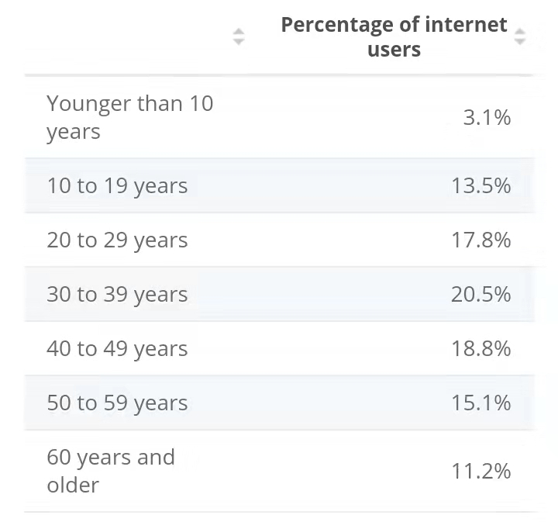

<https://www.statista.com/statistics/265150/internet-users-in-china-by-age/>

The graph shows a breakdown of internet users in China in December 2020, by age group. In December 2020, almost 17.8 percent of internet users in mainland China were between 20 and 29 years old. The country has a huge mobile user base, driving the growth of the mobile app sector.

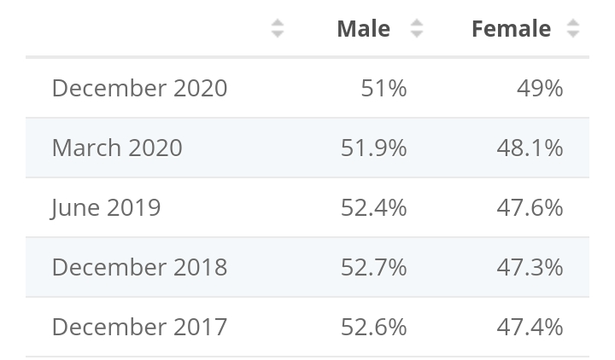

[https://www.statista.com/statistics/265150/internet-users-in-china-by-gender/](https://www.statista.com/statistics/265150/internet-users-in-china-by-age/)

This statistic shows the distribution of internet users in China from 2017 to 2020, by gender. By the end of 2020, about 49 percent of internet users in China were female.

For additional information, in December 2020, around 13.3 percent of the internet users in China earned more than 8,000 yuan per month. China internet users in urban areas account for 73.7% of total internet users. Among the Chinese population who don’t access the internet (which is 541 million), rural areas account for 62.8%. The number of internet users on mobile phones is 847 million, accounting for over 99% of internet users in China. Smartphones have become the top internet access devices in China (chinainternetwatch.com)

2.1.5 Government e-commerce policy for international business

2.1.5.1 The 2019 E-commerce Law

Regarding legal policies in China, a new e-commerce law was announced in August 2018 and came into effect on January 1st of 2019. The new challenges imposed on [overseas sellers](https://melchers-china.com/retail-trends-for-western-brands-in-china-2/) by the new law have the following aspects. Under the new e-commerce law, the overseas seller must designate a Chinese “responsible party”, which will be held directly accountable by the Chinese authorities for consumer complaints, product recall and other product quality or safety obligations. And responsibilities on all the participants in the CBEC supply chain, including the foreign seller, as well as the platform operator and the logistics service providers were restrained by the new law. In addition, China customs and the domestic market regulators are still actively conducting a discretionary inspection and testing of the cross-border products in terms of the national standards. One major concern is that under the new law small businesses which have fewer resources to implement the site development, training and business model adaptations are also required to be fully compliant. The new law therefore creates a higher cost of entry.

The law constitutes the following:

1. The law clarifies the main types of businesses it governs:

• Legal persons or unincorporated organizations that provide a platform for digital business, transaction matching, information release and other services to facilitate parties in an e-commerce transaction, e.g. Alibaba’s Tmall.

• Third party merchants that sell goods or provide services on an e-commerce platform, e.g. a vendor operating a store within Taobao.

• Online sellers operating through their own websites or social media applications, e.g. WeChat shop.

Except for very few types of rare and small personal business, the new law requires all e-commerce operators to handle business registration. Where a special license is required (e.g. food or drug related), such licenses shall be obtained according to law.

2. E-commerce operators must meet their tax obligations and are now required to issue a tax invoice (发票). A marketplace platform has the legal obligation to report merchant identity and tax-related information to the tax authorities and shall keep transaction related information for at least three years.

3. E-commerce platforms are required to establish rules to protect IP rights and retailers must register with the State Administration for Industry and Commerce for a business licence. Non-compliant platforms now face fines of up to $300,000. E-commerce platforms must take joint responsibility with the individual stores on their shop for the sale of fake goods, where previously it had been down only to the individual merchant. Platform operators not responding to claims of fake merchandise can now be fined as much as $30 million.

4. All e-commerce operators face fair competition obligations, with those occupying dominant market positions prohibited from excluding or restricting competition.

5. The new law further fosters consumer protection by requiring the e-commerce operator to disclose accurate product/service information and to avoid engaging in misleading and deceptive practices. E-commerce platforms will also have to establish a system to post consumer comments and introduce other measures to ensure accurate information (Source: China.org.cn). Fake and incentivised reviews are banned.

6. The new law further enhances China’s regulations on privacy protection. The new e-commerce law places restrictions on abuses of consumer profiling, such as forcing consumers to “opt-out” of particular services.

(Source: melchers-china.com, 2019)

2.1.5.2 The 2021 New Rules Addressing Live-Streaming

At the annual [315 consumer rights protection gala](https://www.reuters.com/article/us-china-consumerday-explainer/explainer-what-is-chinas-consumer-rights-day-idUSKBN2B403G) held on March 15 2021, China’s State Administration for Market Regulation have deployed rules pertaining to the recent developments in the sector, which include live streamed sales, user data privacy, and forced exclusivity. The new rule are an important complement to the E-commerce Law that came to effect in 2019.

The rules require platforms which sell via social e-commerce and livestream e-commerce as well as merchants on these platforms to comply with the responsibilities of online transaction marketplaces as described in the law. Selling via live streams and social media are innovations that have gained popularity since the release of the e-commerce law in 2019.

Live stream e-commerce platforms are required keep the videos for at least three years after the end date of the live video session.

The platforms have to gain user consent for the collection and utilization of personal information including biometric data, medical and health information, and financial accounts.

The new rules will also ban services that engage in misleading practices such as falsifying selling volume and audience numbers, or promoting favorable reviews over others.

The guidelines also prohibit practices that facilitate “forced exclusivity,” including suppressing product listing rankings of merchants who decline to sell exclusively on one platform, removing or blocking such online stores, and raising service fees for such sellers.

The measures are important for “improving the online transaction supervision system, regulating the online transaction space, maintaining fair competition, and creating secure online consumption,” a [report](http://www.xinhuanet.com/fortune/2021-03/16/c_1127214829.htm) from state-backed news agency Xinhua cited the regulator as saying. (Emma Lee, technode.com, 2021)

## 2.2 New Trends in Marketing

2.2.1 Definition and Characteristics of Live Streaming

Live streaming refers to online streaming media simultaneously recorded and broadcast in real-time. User interaction via chat rooms forms a major component of live streaming. Platforms often include the ability to talk to the broadcaster or participate in conversations in chat.

Social media marketer Bryan Kramer describes live streaming as an inexpensive "key marketing and communications tool that helps brands reach their online audience." Users can follow their friends' live video "shares" as well as "shares" related to specific content or items. Live media can be shared through any Internet website or application; thus, when people browse on a specific website, they may find live media streams relevant to the content they look for.

With live streaming becoming a financially viable market, particularly for esports, streamers and organizations representing them have looked for metrics to quantify the viewership of streams as to be able to determine pricing for advertisers. Metrics like maximum number of concurrent viewers, or number of subscribers do not readily account for how long a viewer may stay to watch a stream.[25] The most common metric is the "Average Minute Audience" (AMA), which is obtained by taking the total minutes watched by all viewers on the stream during the streamed event and for 24 hours afterwards, divided by the number of minutes that were broadcast. The AMA is comparable to the same metric that the Nielsen ratings for tracking viewership. This also makes it possible to combine standard broadcast and streaming routes for events that are simulcasted on both forms of delivery to estimate total audience size.

2.2.2 Classification of Live Streaming Platforms

Common types of live streaming platforms in China include entertainment, lifestyle, gaming, knowledge sharing, sports, and shopping, that is the focus of this research.

Shopping live-streaming relies on influencer marketing to make a profit. There are two types of live-streaming for shopping: one has its own online shopping platform like Tmall or Taobao, it makes a profit through selling products and aim to create a closed-loop from platform traffic to transaction. The other one is the content platform like Douyin, it doesn’t have its own online marketplace and has to rely on traffic for survival. These platforms either sell their traffic to online shopping platforms like Taobao and JD.com for entry traffic or other platforms for an advertising fee.

Shopping live-streamers are mostly selected to be good-looking and attractive, they have professional knowledge, value consumers, know how to interact through live streaming and understand what customers like.

2.2.3 Influencers and KOL’s

A newly emerging role of influencers and key opinion leaders (KOL) has become increasingly important in the environment of Internet marketing in China. An influencer is a digital user who possesses an enormous amount of followers on social media platforms. The factor that makes influencers valuable to a business is that anytime they publish content online, it will inevitably receive a large quantity of views, likes, comments and reactions. This can be very influential in terms of marketing a brand. Due to that, influencers have become an indispensable component and a go-to person to collaborate with when implementing a digital marketing strategy. However, when choosing an influencer, there are a lot of factors that should come into enterprise’s consideration. Besides being charismatic, the right influencer should be able to be congruent with the values of the company and clearly communicate its message. If the influencer’s reputation or lifestyle don’t align with the company’s vision and mission, the influencer’s following won’t perceive the message as a legitimate testimonial. Another important factor that comes into play when choosing an influencer to represent a brand is the type of audience that comprises their following. The audience’s hobbies, interests, habits and lifestyle should be closely related with that of the business’s target consumers. The reason why influencers are more relevant to the consumer in certain marketing scenarios is that they are more often perceived as being closer to people than a widely famous celebrity.

KOL’s on the other hand are key opinion leaders by definition, which that besides possessing similarly large amounts of following on social media, they are perceived by the public as domain experts possessing deep knowledge in a specific area. In the Chinese marketing environment KOL’s represent one of the most important instruments in communicating marketing messages.

# 3 Theoretical Analysis

## 3.1 Study on Buying Behavior

### 3.1.1 Definition of consumer buying behavior

It is important to note the distinction between consumer behavior and buying behavior, since consumer behavior refers to the study of individuals and groups and their activities related with purchase, use and disposal of goods and services, and how different factors such as emotions, attitudes and preferences affect buying behavior. It is also necessary to mention that buying behavior can refer to both consumer buying behavior and business buying behavior, and since the focus of this paper is on the consumers, the term buying behavior will be studied in relation to consumers specifically.

The first definition of consumer buying behavior dates back to 1974 and states that consumer buying behavior is “a process, which through inputs and their use though process and actions leads to satisfaction of needs and wants” (Enis, 1974, p.228).

The term has been evolving over time as new definitions appeared in research works. Such that in 2007, the term has been given a broader and clearer definition: “Those acts of individuals directly involved in obtaining, using, and disposing of economic goods and services, including the decision processes that precede and determine these acts” (Schiffman 2007).

### 3.1.2 Stages of decision making process

A consumer’s decision-making process includes five stages that the consumer goes through before the actual purchase. During these stages the consumer recognizes the need, gathers information, evaluates alternatives and makes the purchase decision. After the actual purchase comes post purchase behavior where the consumer evaluates the received satisfaction level. (Kotler&Armstrong 2010, p. 177.) Kotler and Armstrong (2010) suggest during a routine purchase, a few stages of the process can be skipped by the consumer. However, when a consumer faces an unfamiliar and complex purchase situation, all of these five stages that are shown in Figure 1, will be used to complete the buying process.

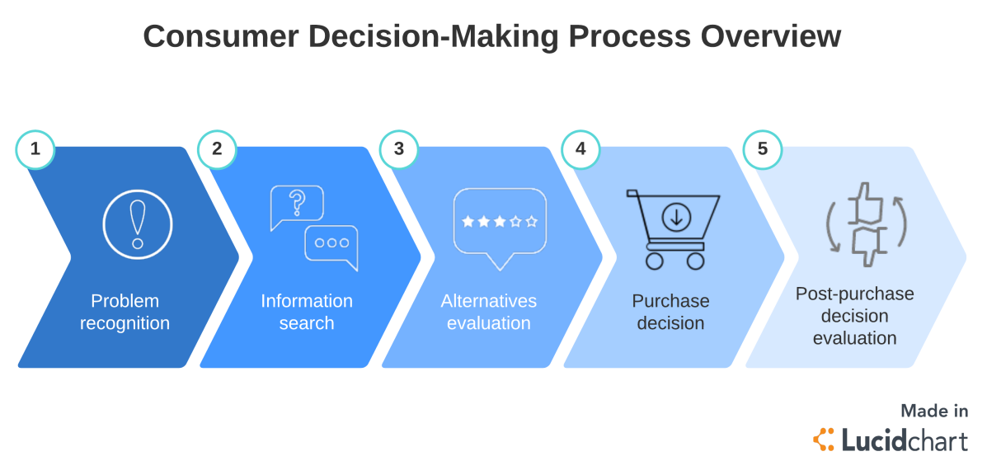

Figure 1. Consumer decision making process

A decision-making process starts with the recognition of need. There are a few types of classifications of need recognition. One type is where the buyer recognizes a need or problem that can be triggered by internal or external stimuli. Internal stimuli are a human’s basic needs, for example hunger that makes stomach grumble and gets the consumer buy a hamburger. External stimuli can be for example an advertisement that can get you to thinking about buying a new computer. (Kotler&Armstrong 2010, p. 178.)

At the second stage of the process consumer starts gathering relevant information. The consumer can get information from multiple sources by talking with friends or family, reading magazines or using the Internet search or handling the product. The amount of the searching will mostly depend on your drive, obtaining of the information and satisfaction got from the search. Nowadays consumers get a huge amount of information from commercial sources that are controlled by marketers. Still, the most effective sources tend to be personal such as family or friends. Consumers can obtain information and increase awareness towards available brands. This information helps consumers to drop some brands when making the final selection of the brand. (Kotler&Armstrong 2010, p. 178.)

After the necessary information has been collected, several alternatives can be evaluated by the buyers. The amount of evaluation will vary from consumer to consumer. In some cases customers make little or no evaluation and make their buying decision based on impulse and intuition. In cases where little or no evaluation of alternatives is used can be originated by a habitual decision process. On the other hand, the consumers who are engaged to an extended problem solving process may carefully evaluate among several brands. The alternatives that are actively considered during the selection process are known as consumers’ evoked set. This evoked set consists of products or brands that are already in the consumer’s memory plus important ones in retail environment. Even if a consumer ponders among many alternatives, the evoked set usually includes only a small number of alternatives. These alternatives share few similar features with each other. (Solomon 2004, p. 305.)

At the fourth stage, the buyer has finished the evaluation process and is ready to proceed to purchase. Usually, the buyers purchase decision will be directed at the most preffered brand. There are factors that can affect the consumer’s buying decision such as the attitudes of others or beliefs about the brand created by marketers. (Kotler&Armstrong 2010, p. 179.) Sometimes to simplify purchasing decisions, consumers can make mental shortcuts that can lead to hasty decisions. Particularly when limited problem solving occurs before making a choice. These kinds of shortcuts can range from universal thoughts like “buy the same brand as last time” or “higher price products are higher quality” to specific “buy the same brand that my mother used to buy”. These shortcuts can turn out to be unfavorable to the consumer. (Solomon 2004, p. 312.)

As mentioned previously, the decision making process continues even after the purchase has been made. The fifth stage is post-purchase decision evaluation. After the consumer has purchased the product, they will evaluate their satisfaction level. If the consumer feels disappointed, the expectations towards the product have not been met. If the product meets expectations, the consumer will be willing to purchase more in the future. In addition, consumer’s high level of satisfaction can lead to brand loyalty, which occurs when consumer’s expectations have been exceeded.

### 3.1.3 The four types of buying behavior

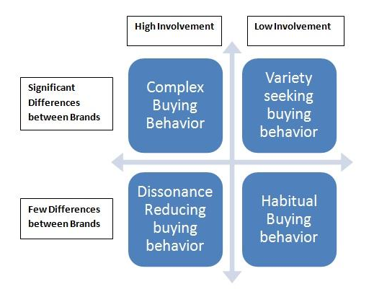

Figure 2. Types of buying behavior.

A consumer buying behavior depends on the product he/she is deciding to buy. Based on observations (Clootrack.com) it is clear that more complex and expensive purchases involve more deliberation and more participants. A consumer buying behavior can be determined by such factors as the level of involvement the buyer shows towards a purchase decision, perceived risks of the purchase etc. As shown in Figure 1, there are four types of consumer buying behavior: complex buying behavior, dissonance-reducing buying behavior, habitual buying behavior and variety seeking behavior.

### 3.1.3.1 Complex buying behavior

Complex buying behavior is mainly encountered when the consumer is contemplating an expensive purchase. This type of behavior will include more hesitation and more thorough research before the commitment to invest. When the risk of purchase s higher the consumer will educate himself on the product he is intending to buy, consult friends and family. He will first develop beliefs about the product, then attitudes, and then making a thoughtful purchase choice.

For complex buying behavior customers, marketers should have a deep understanding of the products. It is expected that they help the consumer to understand about their product. It is important to create advertising message in a way that influences the buyer’s beliefs and attitudes.

Complex buying behavior’s implications for live streaming are evident. Live streaming environment allows for a very natural way of educating the buyer about the product in great detail and helping them form beliefs and attitudes towards the product more easily.

From the aforementioned statements, the following hypotheses can be derived:

H1. Taobao Live successfully handles complex buying behavior because its environment allows users to familiarize with the products in more detail.

H1a: Taobao live provides more detailed information on products in general

H1b: Taobao Live provides more detailed information on products use and features

H1c: Taobao Live provides more detailed information on products quality

H1d: Taobao Live provides more detailed information on products appearance

### 3.1.3.2 Dissonance-reducing buying behavior

The next type of buying behavior is dissonance-reducing buying behavior. This kind of behavior is usually involved when the difference between brands is low, the price is high and the purchase is not frequent. In this case the consumer will buy the product that is more easily available. Based on the products available, limited time or limited budget, consumers will usually make a purchase without much research. It is important for marketers to run campaigns focused on building repeat purchases and referrals by suggesting bonuses and discounts.

Live streaming seems to be suitable to promote such campaigns. Through live streamers influence on the social media, brand announcements can be delivered to more people. The streamers big following community can be attracted, making the product more visible and therefore more available.

From here, another hypothesis can be derived:

H2. Taobao Live successfully handles dissonance reducing buying behavior via providing bigger visibility to the products.

### 3.1.3.3 Habitual buying behavior

Habitual buying behavior happens when the consumer is not highly involved in the purchase and therefore is perceiving only a few significant differences between brands. When buying products daily, consumers don’t give it much thought and simply choose their favourite brand, the one they use regularly or the cheapest one.

For example, while a consumer buys a loaf of bread, he tends to buy the brand that he is familiar with without actually putting a lot of research and time. Many products fit into this category. Everyday use products, such as salt, sugar, biscuits, toilet paper, and black pepper all fit into this product category.

This kind of purchase is based on brand familiarity. Taobao Live in its turn provides a lot of room for building such familiarity. If one particular live streamer or a group of live streamers give reviews to products of one brand, consumers will likely associate the influencers with the brand, which will help them build brand familiarity.

### 3.1.3.4 Variety seeking buying behavior

Lastly, there is variety seeking buying behavior, when consumer involvement is low and there are significant differences between the brands. Here consumers do a lot of brand switching. Since the cost of switching products is low, consumers will tend to try different brands not necessarily out of dissatisfaction, but simply out of curiosity, the need for variety. Marketers usually focus their efforts on turning variety-seeking behavior into habitual.

One the functions of Taobao Live streamers is to entertain the consumer. This is done to encourage the viewer to stay with the brand’s stream for longer. Provided that the consumer has had several positive experiences with a brand through Taobao Live, a habit of watching the same influencers and therefore shopping for the same brand can form, which can help to transform variety seeking behavior into habitual.

3.1.4 Factors affecting consumer buying behavior

There is a wide variety of consumers, each with their own unique desires, needs and experiences. The science behind consumer behavior is much more than studying how people buy. It attempts to understand the mechanism behind the decision-making process and its effect on consumer buying behavior. (Solomon 2004, p. 6-8)

Marketing studies the patterns in consumer buying behavior to recognize what, where, and why they buy. However, the reason behind a consumer’s purchase of a specific product is hard to identify, since it’s locked deep in the consumer’s mind. (Kotler & Armstrong 2010, p. 160.) A consumer’s buying behavior is generally influenced by three major factors, which include social, personal and psychological factors. Consumer behavior is a part of human behavior and by studing previous buying behavior, marketers can estimate how consumers might behave in the future when making purchasing decisions. (Kotler & Armstrong 2010, p. 160.)

3.1.4.1 Social factors

Social factors have significant influence on consumer buying behavior. Every individual’s behavior is influenced by the people that surround them. The important social factors include family, role, status and reference groups. Despite being an individual, every consumer belongs to a group, which is called a membership group. This classification is simple and straightforward. Another type of group is a reference group. The reference group impacts consumer buying behavior by influencing their self-image. The reference group provides comparison opportunity to consumers regarding their habits, lifestyle and behavior. Usually many smaller reference groups are formed by friends, family, co-workers, neighbors or other people consumer regularly interacts with. The third group type is called aspirational groups. These are groups that the consumer does not belong to, yet they can influence their buying behavior. Aspirational groups refer to the groups that the consumer wants to be a member of in the future. (Kotler & Armstrong 2010, p. 164; Khan 2006, p. 58.)

Individual consumers' purchasing decisions may be influenced by family members. The atmosphere in which an individual acquires values, develops, and shapes his or her personality is created by his or her family. This setting allows for the development of attitudes and behaviors, opinions on a number of issues, including social affairs, culture, and politics. A consumer's first impressions of a brand or commodity are formed by his or her kin. (Kotler&Armstrong 2010, p. 169; Khan 2006, p. 68.) For instance, a consumer who formed their brand perceptions in childhood are likely to carry those attitudes into adulthood and may even not realize that their decisions were influenced by their family.

Individuals play many different roles in their lives. Each role consists of activities and attitudes that are expected from an individual to perform according to the persons around him. (Kotler&Armstrong 2010, p. 170.) Social status refers to the position which an individual has in the society that can be influenced by money and wealth, education and occupation. In many societies social status is important and people strive to achieve admiration of others. Product and brand selection often reflects social status of the buyer.

From here we derive the hypothesis that:

H3. Taobao Live is influencing buying behavior, because it provides a highly interactive platform both among users and between the users and the company.

3.1.4.2 Personal factors

Consumer’s purchase decisions are also significantly affected by such personal factors as their age, economic situation, occupation, life-style, character and self-concept.

Consumers’ change during their life and buying of products alter depending on age and stage of life. Age related factors are such as taste in food, clothing, recreation and furniture. Moreover, environment, values, lifestyle, hobbies and consumer habits evolve during lifetime. Family life stages change purchasing behavior and brand selection. Traditionally a family life cycle included only young singles and married couples with children. Nowadays marketers are focusing on alternative, nontraditional stages such as unmarried couples, childless couples, same sex couples, single parents and singles marrying later in life. (Kotler & Armstrong 2010, p. 170.)

A consumer’s occupation and purchasing power influence purchasing decisions and buying behavior. The income level affects what consumers can afford and the perspective towards money. People, who share similar occupations, tend to have similar taste in music, clothing and leisure activities. They usually socialize with each other, and share the same kind of values and ideas. Income level affects on what consumer can afford and perspective towards money. (Solomon 2004, p. 12.)

Modern live streaming platforms successfully leverage big data and machine learning algorithms in order to personalize product suggestions based on consumer data, such as age, gender and possible interests. This implies that live streaming services are successful in affecting buying behavior partially because of being able to target user’s personal factors discussed in this chapter.

3.1.4.3 Psychological factors

Consumer’s choices are also influenced by the four psychological factors, such as motivation, learning, perception, and beliefs with attitudes.

Each person has their own unique needs, which can be biological, like thirst, or psychological, like the need for belonging. Abraham Maslow is probably the most know psychologist who has examined these human needs. He sought to explain why humans are driven by different needs at different times. (Kotler & Armstrong 2010, p. 173.) Figure 3 shows the Maslow’s hierarchy of needs, from the most pressing on the bottom, to the least pressing at the top. The general rule is that the lower need should be satisfied before the higher one arises.

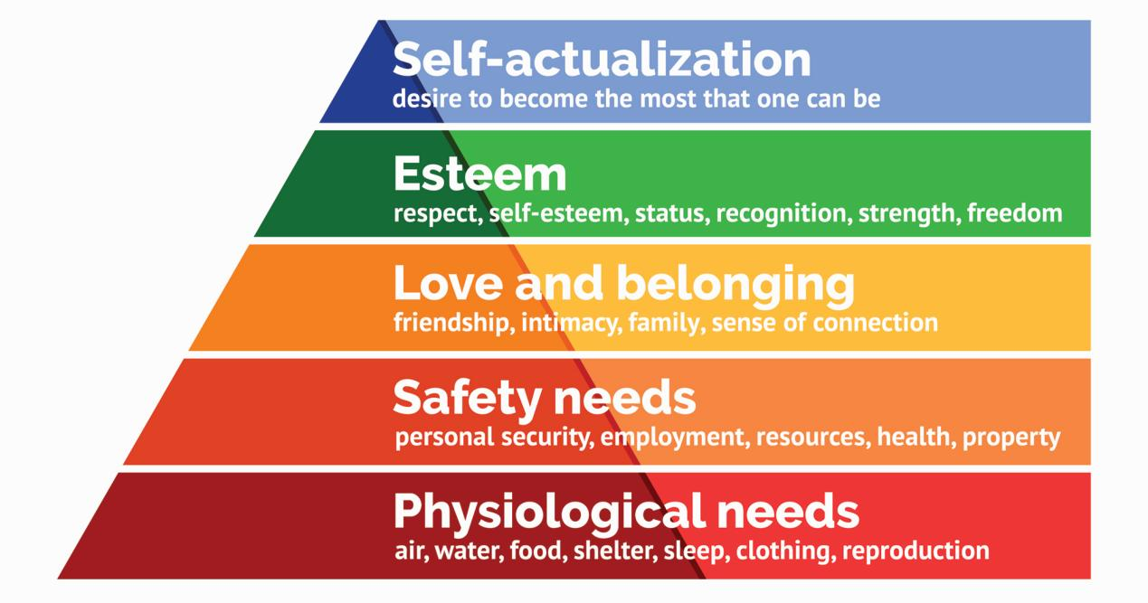

Figure 3. Maslow’s Hierarchy of needs.

When the lower need has been satisfied, it stops being a motive and the person proceeds to fulfilling the next higher need.

A person acts according to his perception of the world and particular situation. Each individual receives a multitude of stimuli daily, such as light, color, sound, texture, smell, taste, etc. Perception is the process through which the stimuli are selected, organized, and used to form a reliable picture of the world. The possibility to form different perceptions is present in people due to three processes: selective attention, selective distortion and selective retention.

At the stage of selective attention, an individual is only focused on the few stimulus he is presented with at that particular moment. Therefore, consumers might neglect all the stimuli that is unrelated to their current need. For example, a person who plans to purchase a house will focus more attention on housing ads, while neglecting ads about automobiles. Selective distortion refers to the process when people interpret information in a way that supports their existing beliefs. Thus, brands advertisement strategies will differ between various consumer groups. When being exposed to an enormous amount of information, people can not retain all of it. Selective retention means that a person will remember the information from particular stimuli. This is demonstrated when customers remember advantages of their favourable brand and forget all the advantages of the brand that is rival to it. (Kotler & Armstrong 2010, p. 174.)

When individuals are motivated, they are ready for action. Action is followed by learning. Learning refers to changes that occur in a person’s behavior emerging after particular experience. People can also learn by observing others, without having their own personal experience. Learning can happen unconsciously. That is known as incidental learning. Consumer’s knowledge of the world changes constantly as they are exposed to new situations and stimuli. They can receive feedback and change their behavior accordingly when exposed to a situation similar to that of the past. (Kotler & Armstrong 2010, p. 175; Solomon 2004, p. 83.) Therefore, it is reasonable to consider that the consumer who had negative experience with a brand’s live streaming is less likely to continue following that brand on the streaming platforms.

After the learning stage is accomplished, people will form beliefs and attitudes towards the object of learning. A belief is a certain way a consumer views something. Beliefs can be based on objective knowledge, opinion or faith. External influence, such as friends or family will influence consumer’s buying behavior. Different kind’s of people will have various kinds of beliefs on the topics of politics, music, food, religion etc. An attitude describes a person’s evaluation of an idea or an object. Both beliefs and attitudes are hard to change. Those are anchored deep in consumers mind and can be part of a person’s personality. (Kotler & Armstrong 2010, p. 175.)

## 3.2 Study on purchase intention

Study on purchase intention is being conducted in marketing for over 20 years. However, there is one question that has yet to come to a consensus in the academic community. It is whether purchase intention can be used to directly predict consumer buying behavior. Four intention-based methods were applied to forecast sales of existing consumer products and services in the research of Armstrong, Morwitz and Kumar (2000). The results have shown that purchase intention is better at predicting sales rather than simple extrapolation of past events.

In the five step process of consumer decision-making described earlier in this paper, marketers relate purchase intention to the fourth step - purchase decision. At that stage the preferences towards specific have been formed and customers are ready to make the purchase. However, preferences and even purchase intention are not completely reliable predictors of purchase decision (Kotler, 2010). Two general factors can somehow interfere between the purchase intention and the purchase decision. Those factors are unexpected circumstances and attitudes of others. Although it is not inside our scope of live streaming research, where consumers are able to make a purchase at any time after they have observed the product, which excludes a large amount of unanticipated circumstances, it is still however very important to understand the multitude of variables that come into play when we discuss an elusive concept like buying behavior.

Business Dictionary gives a simple definition to purchase intention - a plan to purchase a particular good or service in the future. However the term purchase intention revolves around the concept from behavioral biology - intention. Intention is defined as the subjective probability that one will perform a particular action (Fishbein, 1975).

As mentioned earlier in the paper, purchase intention is vital for decision-making and is directly related to consumer buying behavior. In the modern time, researches have developed purchase intention models based on several views, in order to understand the mechanisms behind it and identify how it is formed.

3.2.1 Purchase Intention Based on Consumer Attitudes

Consumer attitudes consist of feelings, beliefs and behaviors. The three components highly depend on each other and represent the process of how consumers react to particular brands or products.

In the work of Sondergaard,Grunert and Scholderer (2005) the formation of consumer attitudes towards different enzyme production methods has been studied. The results of the study suggested that consumer attitudes are more commonly formed from top to bottom. That means that first consumers have a general attitude to a particular food, and only then the purchase intention can be formed. The research has shown that the more positive consumer attitudes are, the more positive the purchase intention will be.

Analyzing the literature previously written on the topic of the relationship between consumer attitude and purchase intention, we can conclude that purchase intention will highly depend on the formation of attitudes during the first phases of purchase decision making process.

3.2.2 Purchase Intention Based on the Theory of Planned Behavior

The theory of planned behavior (TPB) is a [psychological](https://en.wikipedia.org/wiki/Psychology" \o "Psychology) theory that links beliefs to [behavior](https://en.wikipedia.org/wiki/Behavior" \o "Behavior). The theory maintains that three core components, namely, attitude, subjective norms, and perceived behavioral control, together shape an individual's behavioral intentions. In turn, a tenet of TPB is that behavioral intention is the most proximal determinant of human social behavior.

Human behavior is guided by three kinds of considerations: behavioral beliefs, normative beliefs, and control beliefs. In their respective aggregates, behavioral beliefs produce a favorable or unfavorable attitude toward the behavior, normative beliefs result in a subjective norm, and control beliefs pertain to perceived behavioral control.

In combination, the attitude toward the behavior, the subjective norm, and the perceived behavioral control lead to the formation of a behavioral intention. In particular, perceived behavioral control is presumed not only to affect actual behavior directly, but also to affect it indirectly through behavioral intention.

As a general rule, when (a) the individual has a favorable attitude toward a behavior, (b) the attitude is aligned with the relevant norms, and (c) the individual perceives that s/he has a high level of behavioral control, a strong intention to perform the behavior in question is expected. Finally, given a sufficient degree of actual control over the behavior, the individual is expected to carry out his or her intentions when the opportunity arises. (Ajzen, 1985)

3.2.3 Purchase Intention Based on the Technology Acceptance Model

Technology acceptance model was developed by Fred D. Davis (1981). The technology acceptance model (TAM) is an [information systems](https://en.wikipedia.org/wiki/Information_systems" \o "Information systems) theory that models how users come to accept and use a technology. Davis (1981) suggested that behavioral intention is what leads people to use the technology, and it is influenced by the attitude, which is the general impression of technology. The model concludes that when people are presented with a new technology, a number of factors will influence their decisions regarding of how and when to use it. According to Davis, there are two major variables that will affect the formation of people’s attitude to the new technology, namely perceived usefulness and perceived ease of use. Perceived usefulness is defined by Davis as the degree to which a person believes that using a particular system would enhance his or her [job performance](https://en.wikipedia.org/wiki/Job_performance" \o "). While perceived ease of use refers to the degree to which a person believes that using a particular system would be free from effort. (Davis, 1981)

Siew Sin (2012) implemented the technology acceptance model as the basis of his reasearch, and found the positive relationship between the perceived usefulness of social media in Malaysia and the Malaysian consumers’ willingness to buy from social media. At he same time, Malaysian consumers will have more willingness to purchase the products online, if the purchase and delivery processes are perceived by them as easy. (Sin, 2012)

## 3.3 Study on OCE (Online Consumer Engagement)

3.3.1 Definition

In the studies of marketing the concept of online consumer engagement has become a new are of interest. The engagement has been discussed by several researches, and several definitions have been given to the subject. Consumer engagement has been described as the non-directional manifestation of consumer behavior towards a brand which includes activities such as review, recommendations, suggestions to other consumers, etc. (van Doorn, 2010) Since purchase decision making process includes information search as one of its stages, online activity such as watching live streams is directly related to consumer buying behavior and therefore can be referred to as a type of online consumer engagement. Innovations in the Internet technologies have drastically changed the way companies communicate marketing messages to their consumers and potential customers. Social media and other online platforms have become the medium where consumers can be engaged and immersed in the brand offerings (Reitz, 2012).

Connecting and communicating with consumers has been made extremely easy with the coming of live streaming platforms. Online consumer engagement can be seen as the combination of cognition and process orientation that serve as the emotional forces driving the consumer to participate and engage in active transactions (Reitz, 2012). When consumers engage with the brand’s offerings through a website or an application, they get mentally immersed into the medium before being engaged.

It is important for this research to draw a line between involvement and engagement. Although their definitions and functions are similar to each other, involvement merely includes readiness to consume by allocating mental resources, while engagement refers to a more immersive and active way of consumer-brand interaction. Engagement can be described as actively committing to the brand both cognitively and effectively by the means of its engagement channels. (Mollen and Wilson, 2010)

3.3.2 Influence on Purchase Intention

Literature suggests that there is a strong connection between online consumer engagement and buying behavior/purchase intention.

It is important that consumers interact with a website and perceive that the interaction is “two-way, controllable, and responsive to their actions” (Mollen & Wilson, p. 921).

After consumers interact with a website, they experience telepresence, which is the psychological state of “being there” in a computer-mediated environment (Mollen & Wilson, 2010). In other words, consumers perceive themselves to be “steeped in and interacting with an environment” (Mollen & Wilson, p. 921).

According to Shang (2006), participation (e.g., posting messages and lurking in the space) in the Apple Software virtual community influenced loyalty toward Apple software. This study shows a relationship between participation in a branded space and loyalty toward the brand.When consumers are cognitively engaged in a brand, their knowledge/information and learning about the brand increases, therefore, promoting consumer loyalty (Shang, 2006).

From that we derive our final hypothesis about Taobao Live:

H4. Taobao Live influences buying behavior because it provides a platform, where consumers can be highly engaged with the brands and form brand loyalty.

# 4 Methodology

## 4.1 Choice of the Research Method

Qualitative approaches and quantitative approaches are related to discussions on the aspects of quantity and quality of a social phenomenon. Different research methods and

research techniques have the research function of these two aspects. (Creswell 2014, 13)

Qualitative research is expressed in words. It is used to understand concepts, thoughts or experiences. This type of research enables you to gather in-depth insights on topics that are not well understood.

Common qualitative methods include interviews with open-ended questions, observations described in words, and literature reviews that explore concepts and theories.

Qualitative research is the type of method that judges the nature, development and characteristics of an object mainly based on the experience and intuition of the analyst.

Marshall and Rossman (1989) showed that interview, observation and literature is usually used to collect data and to conduct research based on subjective understanding and qualitative analysis.

Quantitative research is expressed in numbers and graphs. It is used to test or confirm theories and assumptions. This type of research can be used to establish generalizable facts about a topic.

Common quantitative methods include experiments, observations recorded as numbers, and surveys with closed-ended questions.

Bryan and Bell (2011) wrote about quantitative research strategy including a deductive research theory concerning the relationship between theory and research. Furthermore, quantitative research involves different quantities of data to carry out the connection between theory and hypothesis.

According to that, in order to better fulfil the research purpose, which is to show the relationship of live streaming platforms' functionality and change in consumer buying behavior patterns in China, quantitative research method has been acquired for this study. A survey with closed-ended questions has been designed with certain statistical data derived from the respondents' answers.

## 4.2 Designing an insightful survey

A questionnaire about the interaction between Taobao Live and the users of the live streaming platform has been designed in relation to the theoretical part in order to fulfil the goal of this research. The design of the survey is cross-sectional, which is the design that is often used with standard survey-based measurement, such as self-administered questionnaires, in-person and telephone interviews (Fink, 2003). Cross-sectional design focuses on one or many groups during one time period. The survey can take several weeks or sometimes even months to complete. (Fink, 2003). This kind of design has been also called a social survey design by Bryman and Bell (2011). According to Fink (2003), surveys are methods for collecting such information as information about or from a person to compare as well as description or explanation of the person's attitude. The surveyors can obtain information right away, by asking people

to answer questions or indirectly, by that means reviewing oral, written and records of

people’s actions and thoughts. Usually the questions in a survey are arranged into mailed or self-administered questionnaires, it can be on computer or on paper, offline or on the Internet (Fink, 2003). In this research, a self-administered survey has been conducted among Chinese consumers on the internet via the widely used digital survey platform wenjuan.com. The questionnaire has been disseminated by the WeChat social media platform as well as using the online survey spreading service surveymonkey.com.

The aim of the survey is to find which features of live streaming affect consumer buying behavior to the highest degree and why Taobao Live has been so influential in helping consumers to make purchase decisions. It is also expected to help discover the correlation between the sample's personal information (such as age, gender, internet usage habits) and how they are using the service. The questionnaire consists of 14 questions that include basic information about respondents, how much time they spend on the internet and the Taobao Live streaming platform in particular, as well as whether or not they consider certain features of the platform to be especially influential in affecting their buying behavior.

# 5 Results and Conclusions

5.1 Findings and Implications

### 5.1.1 Descriptive statistics

In this part of the survey the collected data from the questionnaire that was uploaded to wenjuan.com is presented. 501 valid response to the digital version of the questionnaire have been collected within thirty days. Analysis of the responses is presented in the following part. Conclusions will be discussed in the next section.

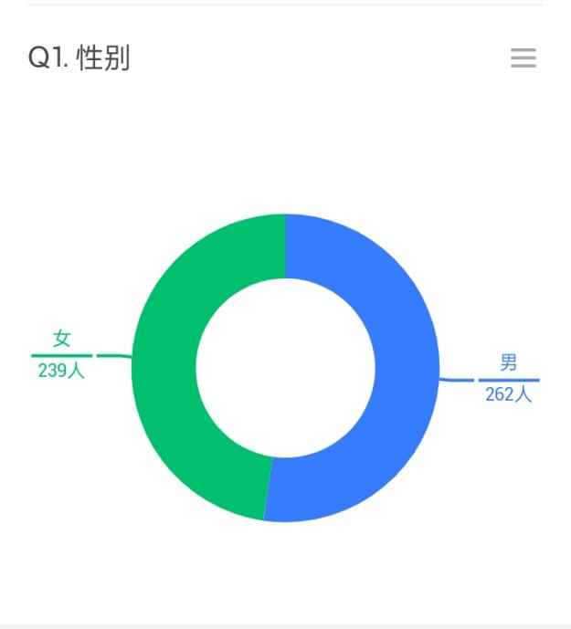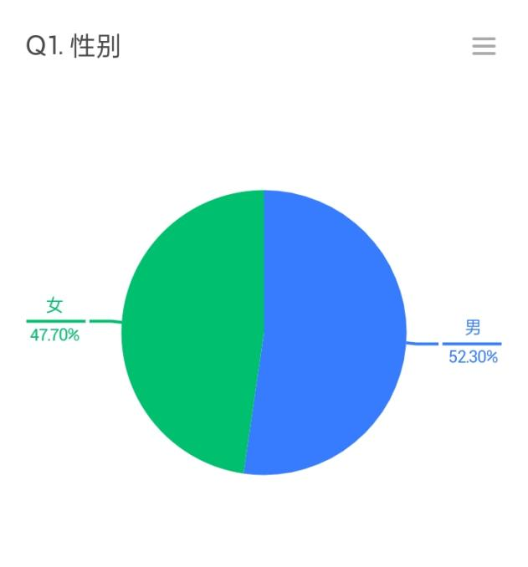

Among 501 participant, there were 239 female respondents which composes 47.70% of the population. The rest respondents were 262 male participants which corresponds to 52.30% of the whole number of participants.

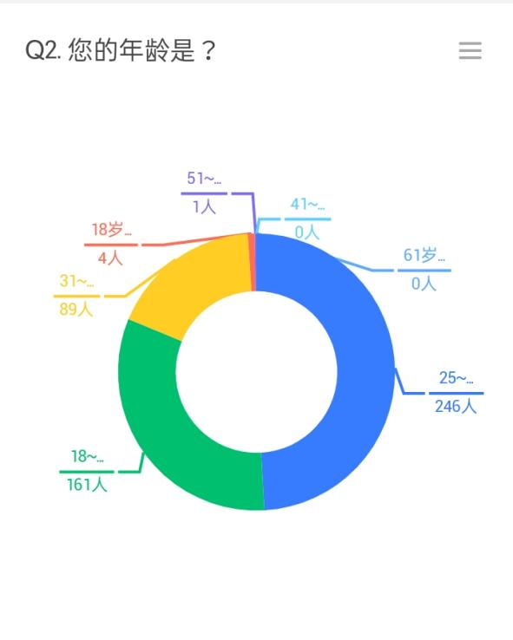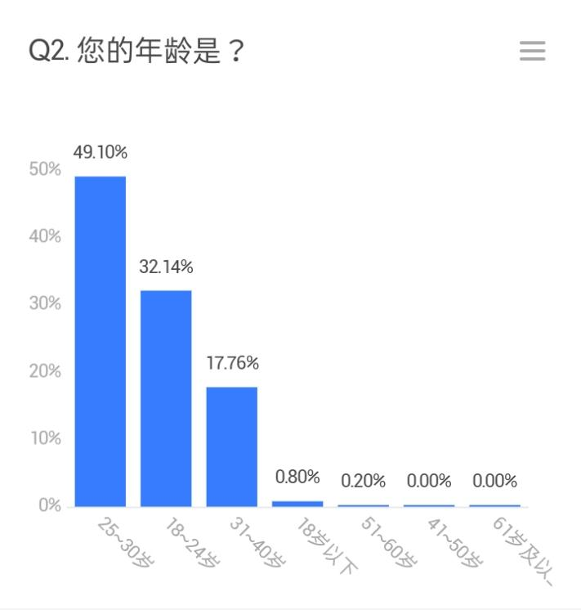

Regarding the population age, 246 participants were between 25-30 years old, which corresponds with 49.10%, 161 person were 18-24 years old, which makes up for 32.14%, 89 people indicated their age as being between 31-40, which composes 17.76% of the population, 4 people specified their age as lower than 18 which is 0.80% of the respondents, and finally 1 person responded with their age between 51-60, that is 0.20% of the population, with 0 respondents being either from 41-50 or older than 61. As it is seen from the results, the majority of participants were in the young adult age group of 25-30. This age group corresponds to the Millenial generation of people born between 1981 and 1996.

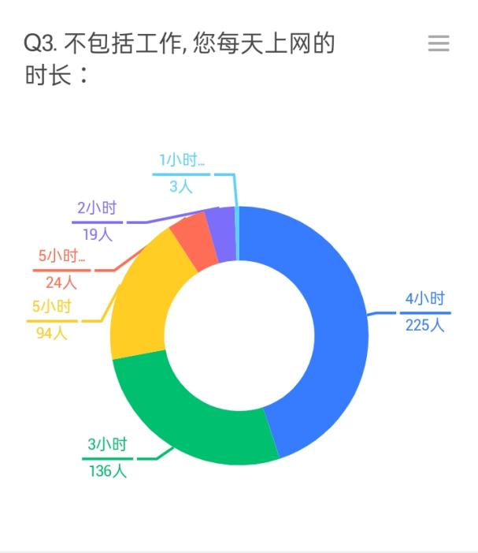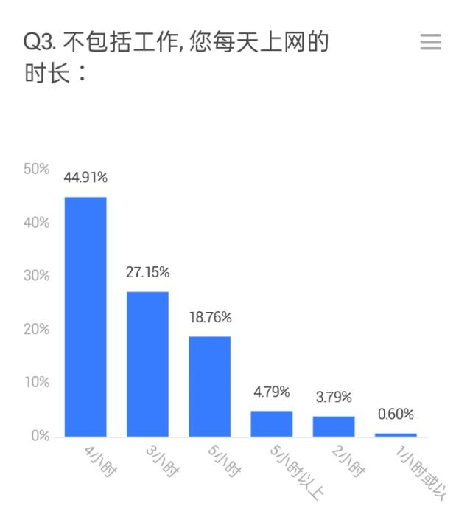

On the question of how much time they spend on the internet not including work, 225 people answered 4 hours (44.91%), 136 answered 3 hours (27.15%), 94 responded with 5 hours (18.76%), 24 claimed to spend more than 5 hours on the internet (4.79%), 19 replied with 2 hours (3.79%), and only 3 people replied with 1 hour (0.60%). Mostly, people of the selected population tend to spend 3-5 hours on the internet outside of work.

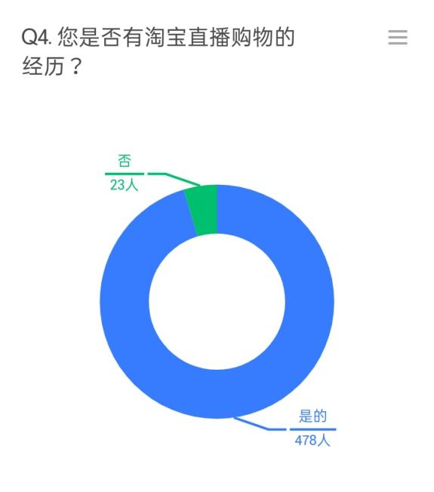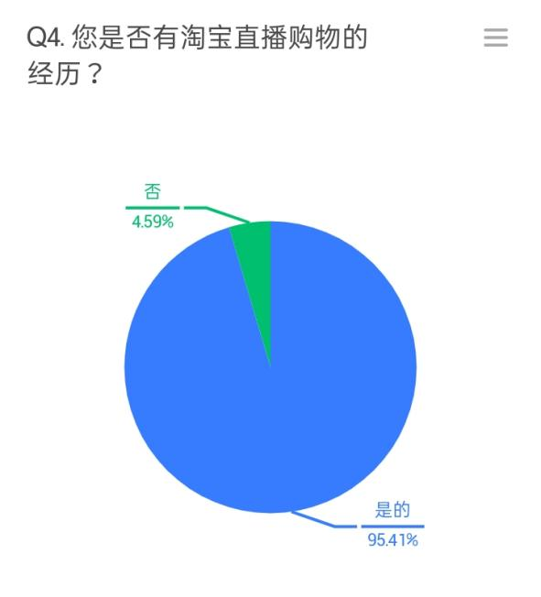

On the question whether or not they have had experience with Taobao Live, the vast majority of the population, which is 478 people (95.41%) replied with yes, which clearly indicates the widespread and popularity of the platform among the Chinese consumers. 23 respondents have not used Taobao Live services before, which accounts to ony 4.59% of the whole population.

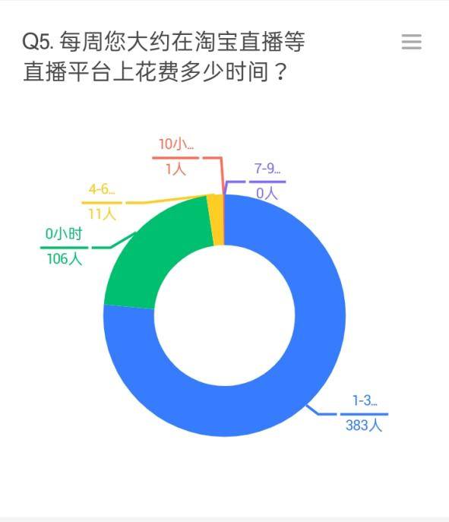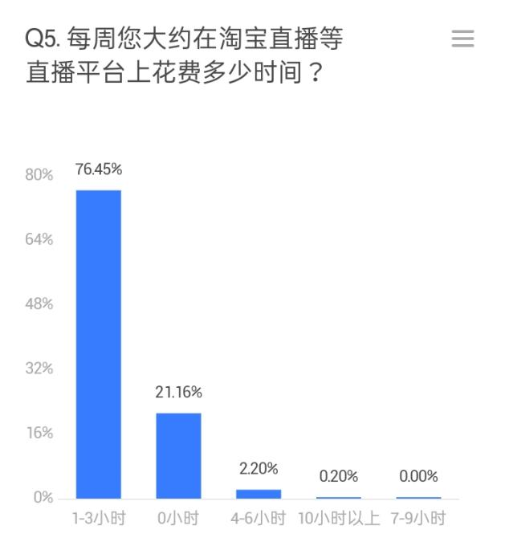

383 respondents (76.45%) indicated that they spend between 1-3 hours a week on Taobao Live and similar live streaming platforms. 106 people responded with 0 hours (21.16%), which can indicate no prior experience with live streaming platforms or less than one hour of time spent on the platforms per week. 11 people replied with 4-6 hours a week (2.20%) and only 1 person claimed to be spending more than 10 hours a week (0.20%), which could account for going on live streaming apps for one and a half hour each day. Apparently, none of the respondents was spending 7-9 hours a week on the platforms.

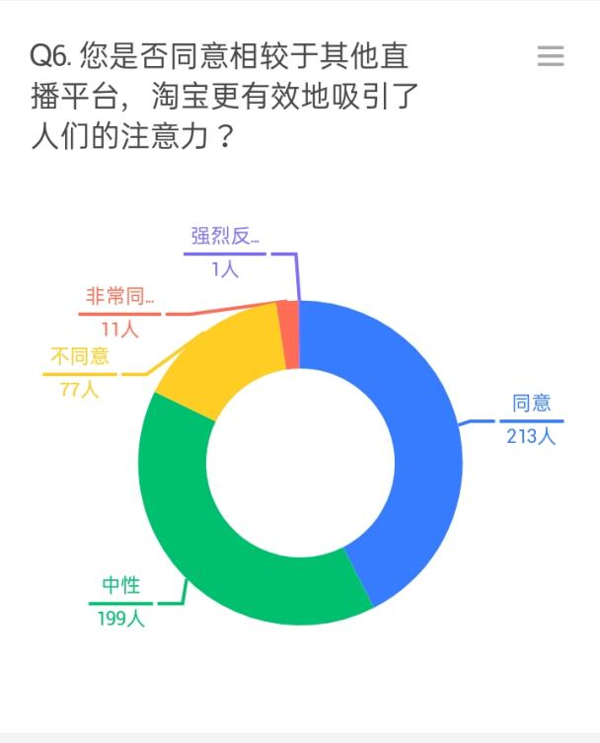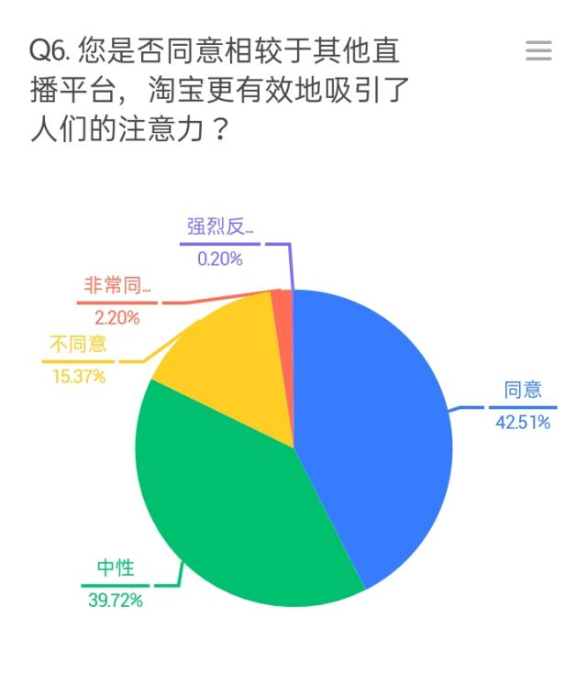

Concerning how efficient in terms of attracting attention respondents consider the platform to be, 213 people (42.51%) agreed that live streaming has provided a better environment for drawing people's attention, while a slightly smaller number of participants, 199 people (39.72%) responded neutral. 77 people (15.37%) did not agree with the statement, 11 people (2.20%) strongly agreed and 1 person (0.20%) strongly disagreed.

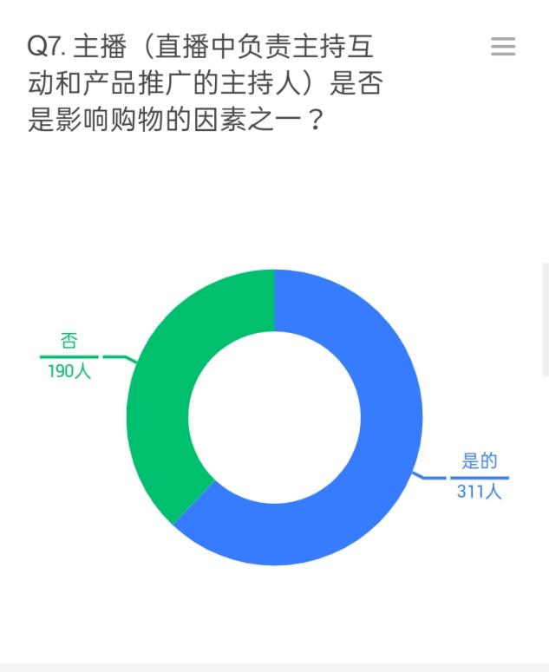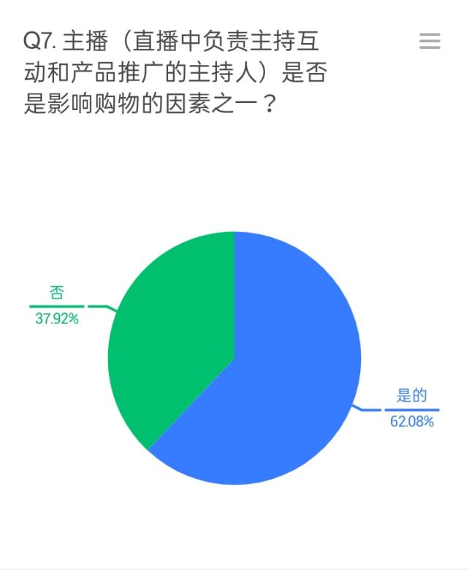

On the question whether or not they consider the presence of the live streamer an important factor in influencing buying behavior, more than a half of the population responded positively, which accounts for 311 people (62.08%). The other part however, 190 people (37.92%), considered the presence of the live streamer insignificant.

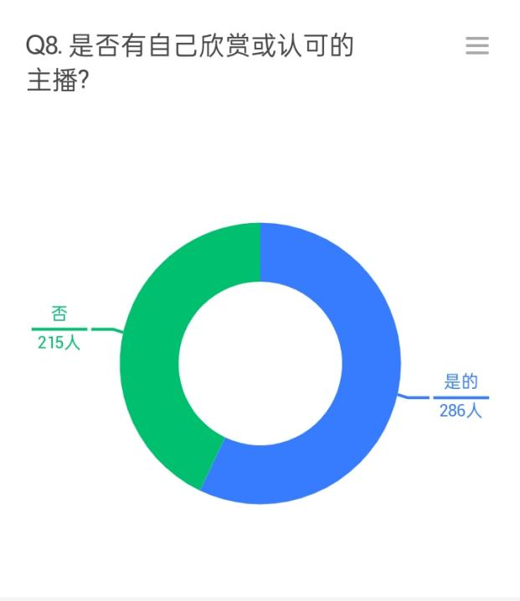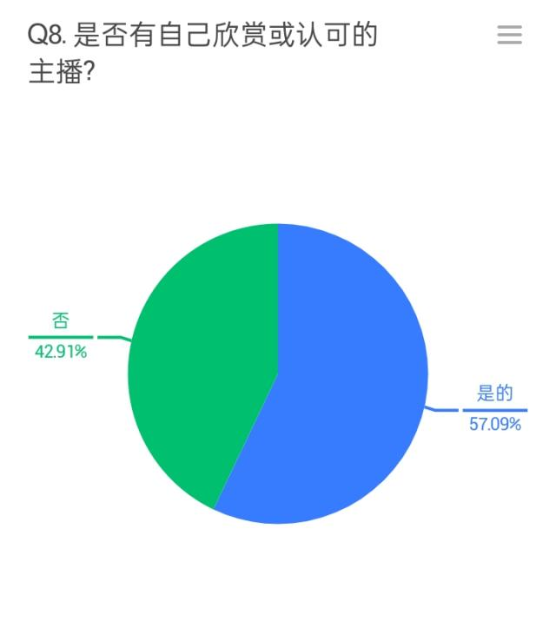

286 people (57.09%), which accounts to more than a half of the respondents, admitted that they have their own favourite live streamer on the platform. The other 215 participants (42.91%) reported not having a favourite live streamer.

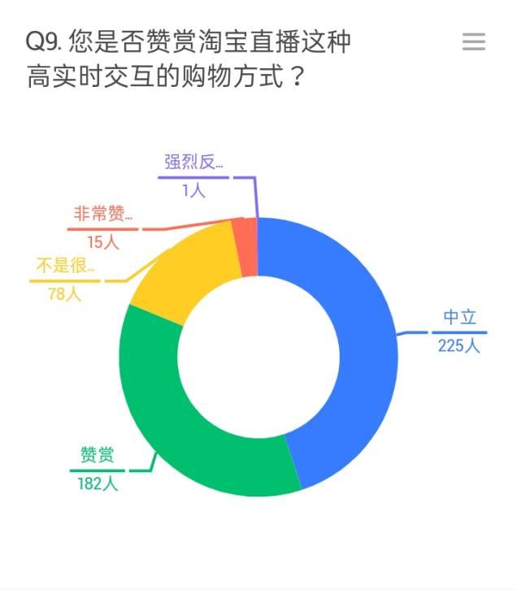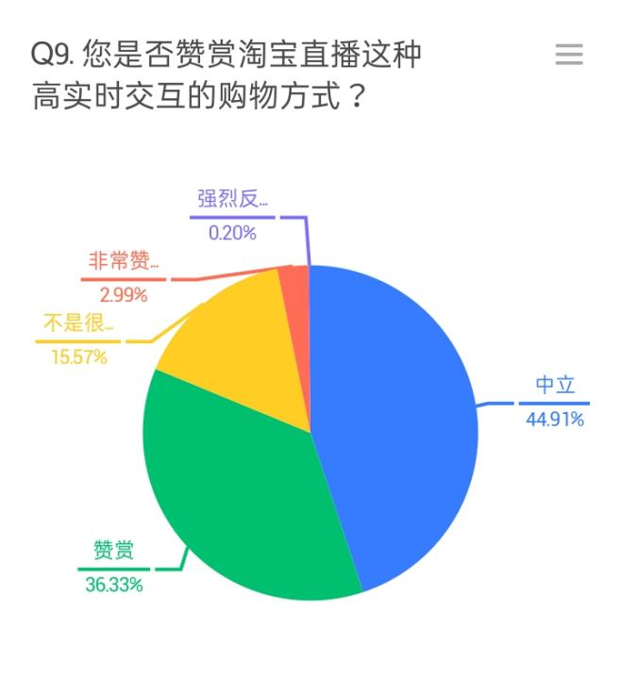

The majority of participants mentioned that they appreciate Taobao as a highly interactive way of shopping, accounting for 225 people (44.91%), while 182 responded neutrally (36.33%). 78 people (15.57%) did not consider the platform to be interactive, 1 person strongly disagreed (0.20%) and 15 people agreed strongly with the statement (2.99%). As a result we have 240 respondents (47%) out of 501 who appreciate or highly appreciate the platform for being interactive, and only 79 (16%) who did not.

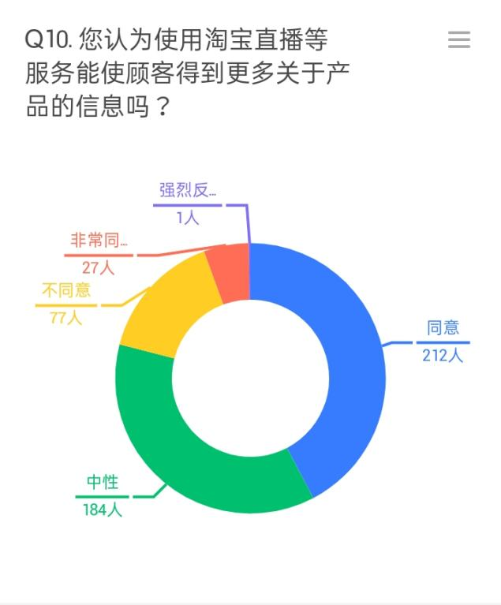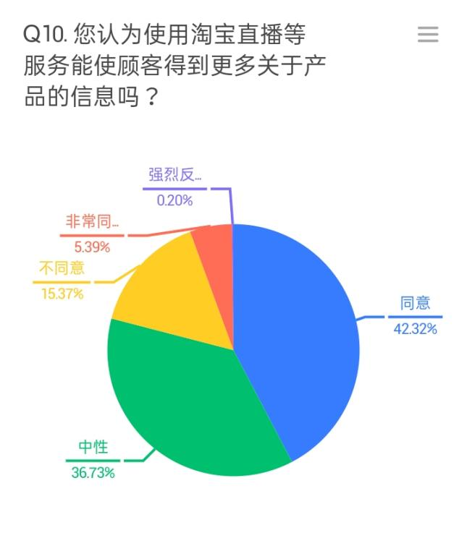

212 participants (42.32%) supposed that through live streaming they can receive essentially more information about the product than through any other medium. 184 people (36.73%) responded neutrally, 77 disagreed (15.37%), 27 people strongly agreed (5.39%) and one person strongly disagreed. This shows that more than a half of the participants either agrees upon live streaming being an informative medium or is neutral about it, with an insignificant number of people having the opposite opinion.

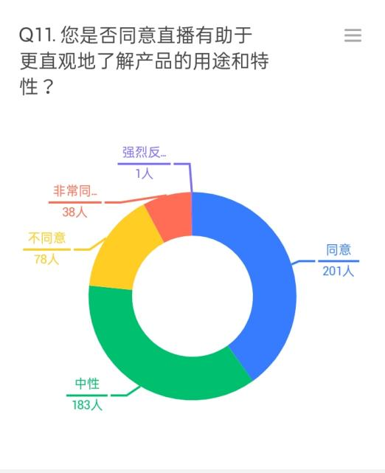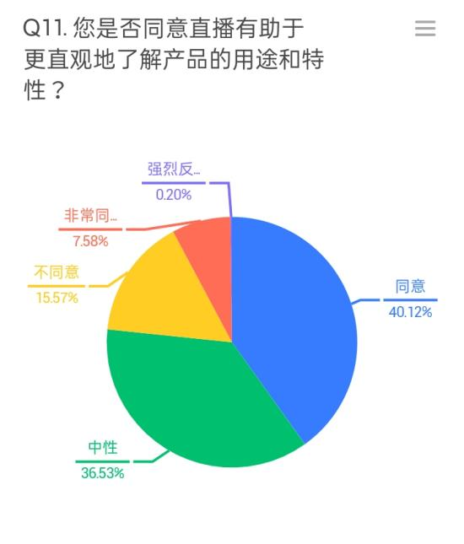

Similar situation with whether or not the respondents consider live streaming to be informative in terms of product use and features. 201 person agreed with the statement(40.12%), 183 remained neutral (36.53%), 78 respondents disagreed (15.57%), 38 people agreed strongly (7.58%) and 1 person strongly disagreed (0.20%).

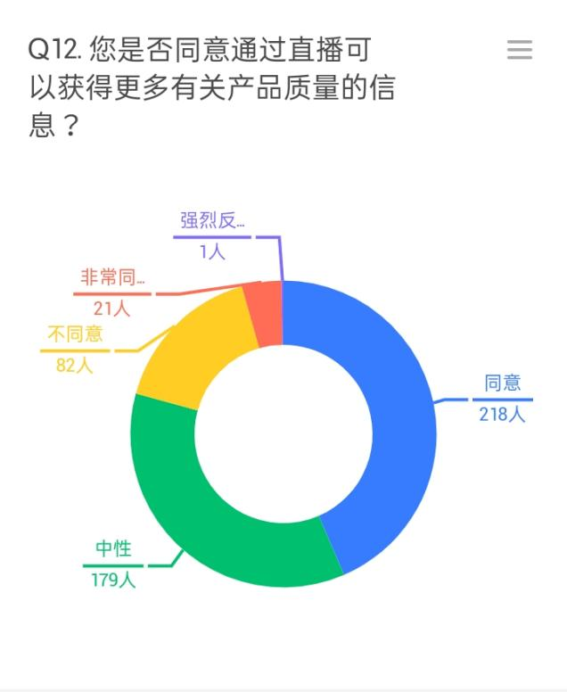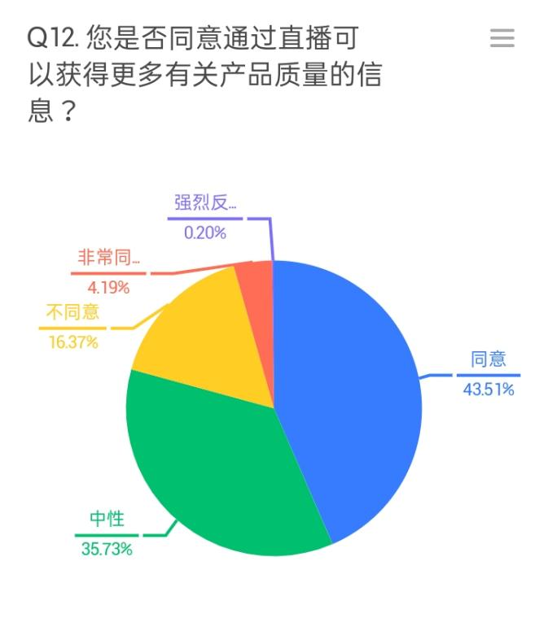

Slightly more people agreed upon live streaming being able to tell consumers more about the product quality, with 218 "agree" responses (43.51%), 179 neutral (35.73%), 82 "disagree" (16.37%), 21 "strongly agree" (4.19%) and 1 "strongly disagree" (0.20%).

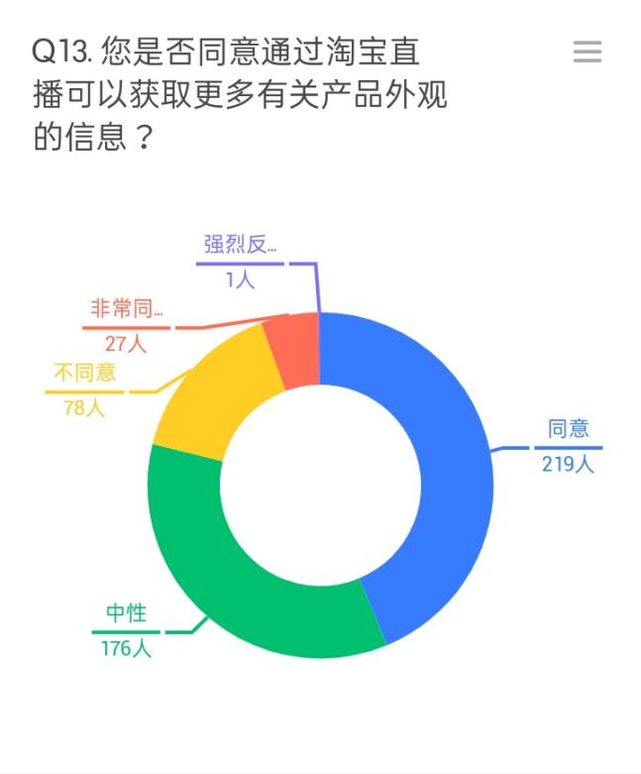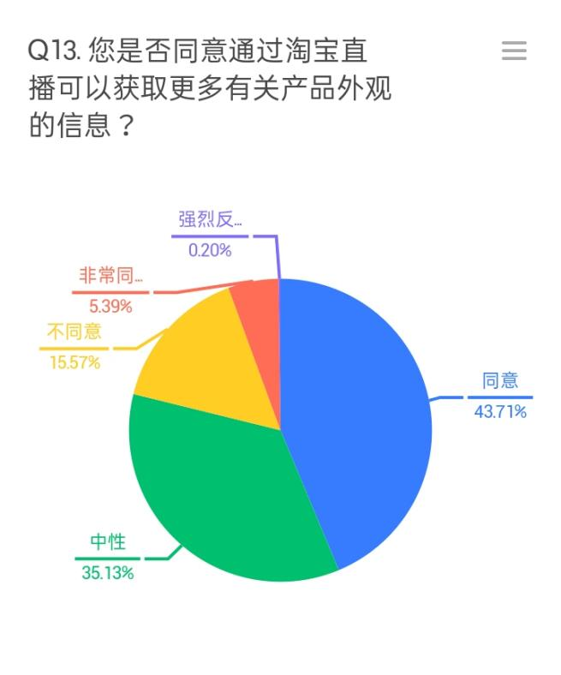

As for the product appearance, 219 people agreed that live streaming can give much information on that (43.71%), 176 people left a neutral response (35.13%), 78 people disagreed (15.57%), 27 participants strongly agreed (5.39%) and 1 person strongly disagreed.

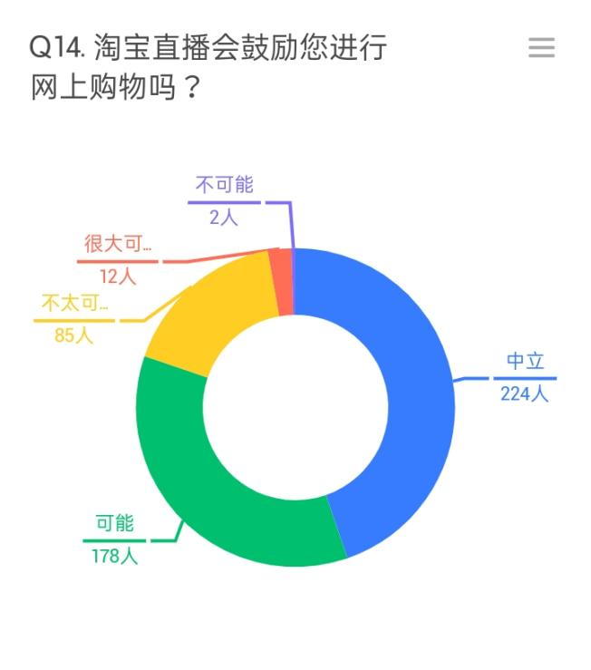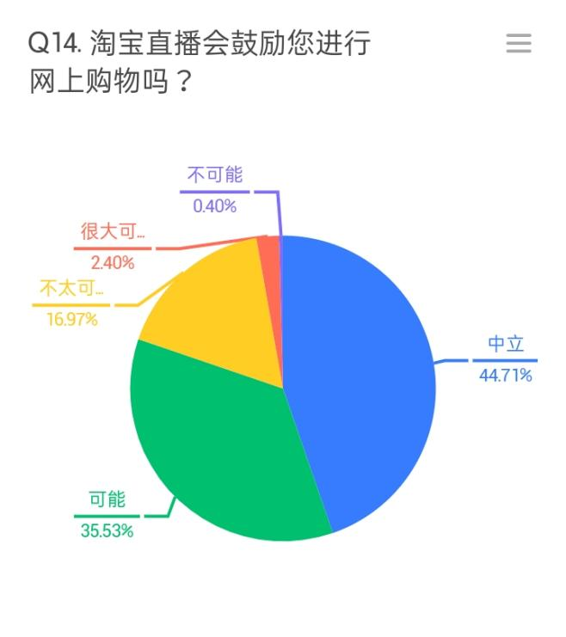

And finally, 224 participants admitted that Taobao Live is likely to influence them to do shopping (44.71%), 178 people responded neutrally (35.53%), 85 people considered that it is not very likely (16.97%), 12 people answered with "very likely" (2.40%) and 2 people replied that it is very unlikely for their buying behavior to be affected by Taobao Live (0.40%).

## 5.2 Testing the hypotheses against the answers

### 5.2.1 H1. Taobao Live successfully handles complex buying behavior because its environment allows users to familiarize with the products in more detail.

From the survey answers on questions 10-14 we make a conclusion about the hypothesis H1, and its components H1a, H1b, H1c, and H1d. Apparently, the majority of respondents either stayed neutral or agreed with the statements that from Taobao Live they can receive more detailed information on products, product use and features, product quality and product appearance, while a significantly smaller number of respondents disagreed. The ratios of positive answers to negative are as follows:

Q10 Do you agree that from Taobao Live you can obtain more detailed information about the products in general? Positive to negative ratio = 239:78

Therefore, H1a: Taobao live provides more detailed information on products in general, is confirmed from the answers to question 10.

Q11 Do you agree that from Taobao Live you can obtain more detailed information about products use and features? Positive to negative ratio = 239:79

Therefore, H1b: Taobao Live provides more detailed information on products use and features, is confirmed from the answers to question 11.

Q12 Do you agree that from Taobao Live you can obtain more information about product quality? Positive to negative ratio = 239:83

Therefore, H1c: Taobao Live provides more detailed information on products quality, is confirmed from the answers to question 12.

Q13 Do you agree that from Taobao Live you can obtain more detailed information about the product appearance? Positive to negative ratio = 246:79

Therefore, H1d: Taobao Live provides more detailed information on products appearance, from the answers to question 13.

Q14 How Likely is Taobao Live to influence you to make a purchase?

Positive to negative ratio = 236:87

Therefore, Taobao Live holds value in influencing buying behavior, from the answers to question 14.

From all of the above, on the theoretical basis provided in part 3.1.3.1 “Complex buying behavior” and having received the statistical data from the survey, we can confirm the hypothesis H1. Taobao Live successfully handles complex buying behavior because its environment allows users to familiarize with the products in more detail.

### 5.2.2 H2. Taobao Live successfully handles dissonance reducing buying behavior by drawing user's attention to the products, therefore providing bigger visibility and perceived availability for consumers.

Considering the question 6 we can make a conclusion about the validity of the H2 hypothesis. It seems like the biggest part of the respondents agreed that Taobao Live does a better job at drawing attention of the users to the products than other live streaming platforms. The ratio of positive to negative responses is as follows:

Q6. Do you agree that Taobao Live is more effective at drawing people’s attention to the products? Positive to negative ratio = 224:78.

From question 6 of the survey and based on the theory provided in part 3.1.3.2 “Dissonance-reducing buying behavior” we can confirm that the hypothesis H2. Taobao Live successfully handles dissonance reducing buying behavior by drawing user's attention to the products, therefore providing bigger visibility and perceived availability for consumers is true.

### 5.2.3 H3. Taobao Live is influencing buying behavior, because it provides a highly interactive platform both among users and between the users and the company.

According to the questions 7-9 we can judge whether or not the H3 hypothesis is true.

Again, the majority of participants gave positive answers to all the three questions.

The ratios of positive to negative responses are as follows:

Q7. Does the live streamer (the person leading the live stream) influence the process of online shopping? Positive to negative ratio = 311:190.

Q8. Do you have a favourite or a familiar live streamer?

Positive to negative ratio = 286:215.

Q9. Do you appreciate Taobao Live as a highly interactive platform?

Positive to negative ratio = 240:79.

Having the answers to questions 7-9 to the survey and the theoretical data from part 3.1.4.1 “Social factors”, we can confirm the hypothesis H3. Taobao Live is influencing buying behavior, because it provides a highly interactive platform both among users and between the users and the company. Consumers are influenced by different individuals, including certain live streamers and key opinion leaders that they admire and strive to be alike with.

Even though the difference between the numbers of users who watch particular live streamers and who don’t is not as significant, it is still indicative of that slightly more than a half of the consumers like interacting with certain influencers of their choice.

### 5.2.4 H4. Taobao Live influences buying behavior because it provides a platform, where consumers can be highly engaged with the brands, and form brand loyalty.

Confirmation of the fourth hypothesis can be found in multiple questions from 3-6 to questions 7-9 that have been discussed earlier in this chapter, hence the topic of interactivity from the previous hypothesis is closely connected with the topic of consumer engagement. In part 3.3 “Study on OCE (Online Customer Engagement)” we have found that based on the theory provided by Mollen and Wilson, (2010) and Shang (2006) in their works concerning the impact of online consumer engagement on purchase intention. Both works suggest the link between online engagement and brand loyalty, which in turn translates to positive consumer behavior. The results of the survey confirm that the hypothesis is also applicable to Taobao Live.

Q3. Not including work, how much time do you spend online every day?

The majority of Chinese consumers tend to spend a significant amount of their time on the internet daily. Most of our respondents gave the approximation of 3-4 hours on the internet daily, which indicates high internet consumption.

Q4. Do you have experience of using Taobao Live?

The ratio of positive to negative answers to this question is 478:23, which means that most of the people taking this survey have the live streaming experience with the particular platform of Taobao Live.

Q5. How much time do you spend on Taobao Live weekly?

The absolute majority of people taking our survey spent anywhere from 1-3 hours a week on Taobao Live, while some rare consumers (11 people) could use the platform for 4-6 and even 10 hours a week (1 person). This indicated medium to high engagement with the live streaming platform.

In addition, having analyzed the answers on questions 7-9, we can see that the replies are quite indicative of high interactivity and consumer engagement, since most of the respondents have consider the presence of the live streamr important, have their own favourite live streamer and appreciate Taobao Live as a highly interactive platform.

From all of the above, we can confirm the truthfulness of H4. Taobao Live influences buying behavior because it provides a platform, where consumers can be highly engaged with the brands, and form brand loyalty.

## 5.3 Implications for International Businesses

Having conducted this research on how Taobao Live influences consumer buying behavior in China, there are several suggestions to be proposed for international businesses planning to penetrate Chinese market.

The first advice to be made is on targeting the right age-group of consumers. While the Internet technology is highly developed and widely available in China, still not all the consumer age-groups are particularly engaged in using live streaming services. Most of the people who took our survey were young adults from 25 to 30 years old, followed by the younger users 18-24 and mature consumers 31-40. The technology acceptance coefficient, discussed earlier in this paper, is lower among the elder people 41-50, 51-60 and above. Therefore it is reasonable to target relatively younger audiences when implementing the live streaming marketing strategy for the Chinese consumers.

Following considerations of choosing correct age-groups to target, it is also important to choose the right product for such marketing campaign. Products that are likely to involve complex buying behavior, such as expensive consumer electronics and other rarely bought products that require certain degree of responsible research from the user can be effectively promoted by live streaming services. Meanwhile, products that could involve dissonance-reducing buying behavior, such as jewelry, or other products that are widely available on the market but sometimes require a fast purchase, can also be marketed by using live streaming.

As concluded from the previous literature, choosing the right live streamer is also crucial to the success of the online marketing campaign. The influencer should meet the values of your business and have followers that have corresponding lifestyle and interests with what the business provides. For instance, if the key opinion leader is creating content about sports and healthy lifestyle, it might not be the best option to advertise alcohol drinks to their audience. It is important to research the background of the chosen live streamer and it is advised to use services of marketing services that will pick the right individual for introducing your product to Chinese consumers by live stream.

Last but not least, all the foreign businesses must strictly abide by the Chinese e-commerce laws when running online marketing campaigns for Chinese consumers. All foreign sellers must have a Chinese responsible party to be held accountable for consumer complaints, product recall and other product quality or safety obligations. In addition, foreign e-commerce operators must always meet their tax obligations and issue tax invoice. Finally, all the information provided by the online traders about the product should be full and true.

## 5.4 Study Limitations

As mentioned previously, the survey created for this research was uploaded to several web sites where it was shown to a certain number of Chinese consumers, and 501 responses were collected in one month period. Therefore, it is necessary to admit that this survey provides analytical results for only a small part of Chinese consumers. In addition, since the survey was conducted through the internet, remotely and from outside of China, it wasn’t able to gather enough answers from the elderly people, who may not be as active in taking online surveys.

## 5.5 Suggestions for Further Research

Several points were left undiscovered in this paper. For instance, how the gender difference affects the usage of Taobao Live and its influence on buying behavior. In addition, since, as mentioned before, this survey represents the effect on buying behavior of only a small population of certain age groups, further research could be conducted among a larger sample size and include older age groups.

# Reference

# Thedrum.com, 2021, "Digital ad revenue in China grew in 2020 – despite coronavirus spending cuts". https://www.thedrum.com/news/2021/01/14/digital-ad-revenue-china-grew-2020-despite-coronavirus-spending-cuts

# Enis, B.M. (1974) “Marketing Principles: The Management Process”

# Schiffman L., Hansen H. and Kanuk L. (2007) “Consumer Behaviour: A European Outlook”, London: Pearson Education

# Clootrack.com, "Types of Consumer Behavior". https://clootrack.com/knowledge_base/types-of-consumer-behavior

# Hans B., Jan-Benedict E.M. Steenkamp (1994) "Exploratory consumer buying behavior: Conceptualization and measurement"

# John W. Creswell, (2014) "Research Design: Qualitative, Quantitative and Mixed Methods Approaches"

# Bryman A., Bell E., (2011) "Business research methods"

# Marshall C., Rossman G.B., (1989) "Designing Qualitative Research"

# Fink A. (2003) "The survey handbook"

# Kotler P., Armstrong G., (2010) "Principles of Marketing"

# Richard Mayer, (2003) "Internet Marketing: Strategy, Implementation and Practice"

# Melchers-China.com "China’s new e-commerce law improves online market regulation". https://melchers-china.com/chinas-new-e-commerce-law-improves-online-market-regulation/#:~:text=The%20new%20law%20further%20enhances,-out”%20of%20particular%20services.

# Michael R. Solomon (2004) "Consumer Behavior: Buying, Having, and Being"

# Michael R. Solomon, Garry J. Bamossy, Søren Askegaard and Margaret K. Hogg (2013) "Consumer Behavior: A European Perspective"

# Icek Ajzen, Martin Fishbein, and Ned A. Flanders (1975) "Belief, attitude, intention and behaviour: An introduction to theory and research"

# J. Scott Armstrong, Vicki Gail Morwitz, V Kumar (2000) "Sales Forecasts for Existing Consumer Products and Services: Do Purchase Intentions Contribute to Accuracy?"

# Emma Lee, Technode.com 2021 "New e-commerce laws address livestreams, forced exclusivity" https://technode.com/2021/03/17/china-expands-e-commerce-laws-to-livestreams-exclusivity/

# H.A. Sondergaard, K.G. Grunert, J. Scholderer (2005) "Consumer attitudes to enzymes in food production"

# Icek Ajzen, (1985) "From Intentions to Actions: A Theory of Planned Behavior"

# Fred D. Davis (1989) "Perceived Usefulness, Perceived Ease of Use, and User Acceptance of Information Technology"

# Siew Sin (2012) "Factors Affecting Malaysian young consumers’ online purchase intention in social media websites "

# Jenny van Doorn, Ketherine N. Lemon, Vikas Mittal (2010) "Customer Engagement Behavior: Theoretical Foundations and Research Directions"

# Reitz, Amy Renee (2012) "Online consumer engagement: understanding the antecedents and outcomes”

# Rong-An Shang, Yu-Chen Chen, (2006) "The value of participation in virtual consumer communities on brand loyalty"

# Anne Mollen, Hugh Wilson (2010) "Engagement, telepresence and interactivity in online consumer experience: Reconciling scholastic and managerial perspectives"

# Appendix

Questionnaire

1.性别

男

女

2.您的年龄是？

18岁以下

18~24岁

25~30岁

31~40岁

41~50岁

51~60岁

61岁及以上

3.不包括工作, 您每天上网的时长：

1小时或以下

2小时

3小时

4小时

5小时

5小时以上

4.您是否有淘宝直播购物的经历？

是的

否

5.每周您大约在淘宝直播等直播平台上花费多少时间？

0小时

1-3小时

4-6小时

7-9小时

10小时以上

6.您是否同意相较于其他直播平台，淘宝更有效地吸引了人们的注意力？

非常同意

同意

中性

不同意

强烈反对

7.主播（直播中负责主持互动和产品推广的主持人）是否是影响购物的因素之一？

是的

否

8.是否有自己欣赏或认可的主播?

是的

否

9.您是否赞赏淘宝直播这种高实时交互的购物方式？

非常赞赏

赞赏

中立

不是很赞赏

强烈反对

10.您认为使用淘宝直播等服务能使顾客得到更多关于产品的信息吗？

非常同意

同意

中性

不同意

强烈反对

11.您是否同意直播有助于更直观地了解产品的用途和特性？

非常同意

同意

中性

不同意

强烈反对

12.您是否同意通过直播可以获得更多有关产品质量的信息？

非常同意

同意

中性

不同意

强烈反对

13.您是否同意通过淘宝直播可以获取更多有关产品外观的信息？

非常同意

同意

中性

不同意

强烈反对

14.淘宝直播会鼓励您进行网上购物吗？

很大可能

可能

中立

不太可能

不可能